Saduq Rahman

February 28, 2021

Foundations of Programming, Python

Assignment 7

**CDIventory Python Using Functions**

**Introduction**

In assignment 7 we begin to utilize pickling which in Python is primarily used to serialize and deserialize a Python object structure. In other words, it is the process of converting a Python object into a byte stream to store it in a file/database, maintain program state across sessions, or transport data over the network. The pickled byte stream can be used to re-create the original object hierarchy by unpickling the stream. When a byte stream is unpickled, the pickle module creates an instance of the original object first and then populates the instance with the correct data. To achieve this, the byte stream contains only the data specific to the original object instance. But having just the data alone may not be sufficient. Python has many built-in exceptions that are raised when your program encounters an error When these exceptions occur, the Python interpreter stops the current process and passes it to the calling process until it is handled. If not handled, the program will crash. Error message is displayed, and our program comes to a sudden unexpected halt. Using the “try and except” function helps deal with the error that is being displayed.

**Drafting the Code**.

I used the program spyder to write and test the code being written, my first step was going thru the labs by the teacher in module 7. To try and grasp the concept utilizing functions in addition I spent allot of time watching the YouTube videos both about “pickling” and the “try and except” function. Also, had to read the chapter 7 of (Dawson, 2010) a few times to really get the concept to sink in. When constructing the code that was given to us one of the issues I had was getting to the pickling to work I keep getting unable to find the mark error, but after discussing the issue with the teacher assistant and pointing me in the right direction I begin to understand that I needed to use the parameters in order pass the argument to the function and also let the module know that it should expect a return value back to pass on.

As you’ll see within the figures depicted below:

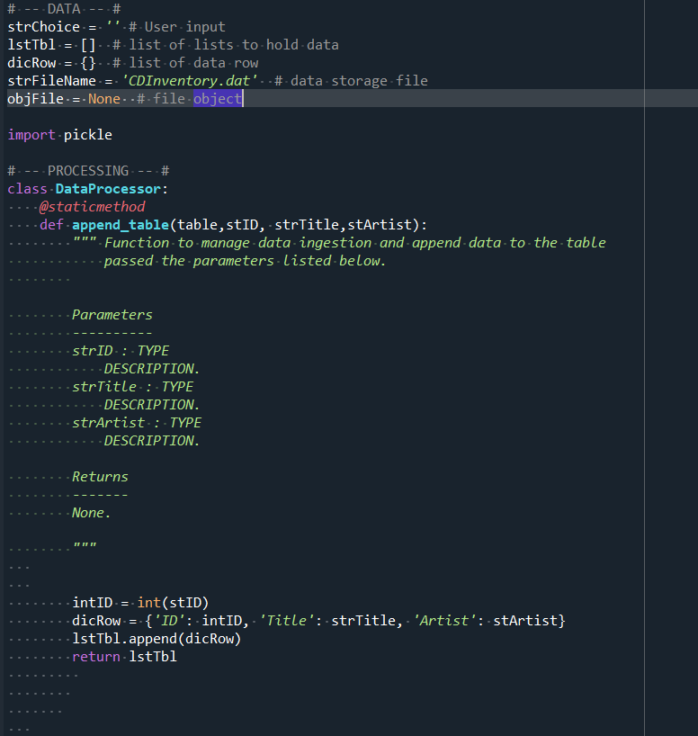

Figure I

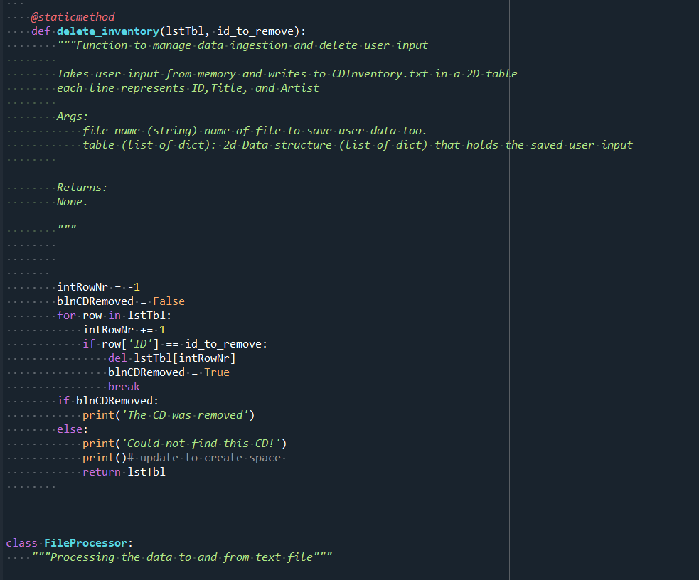

Figure II

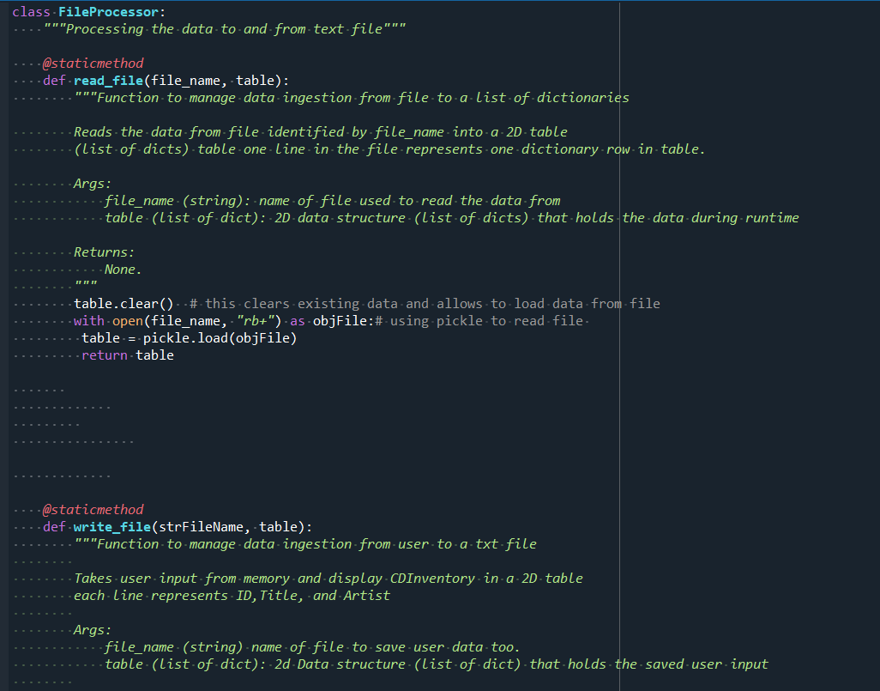

Figure III

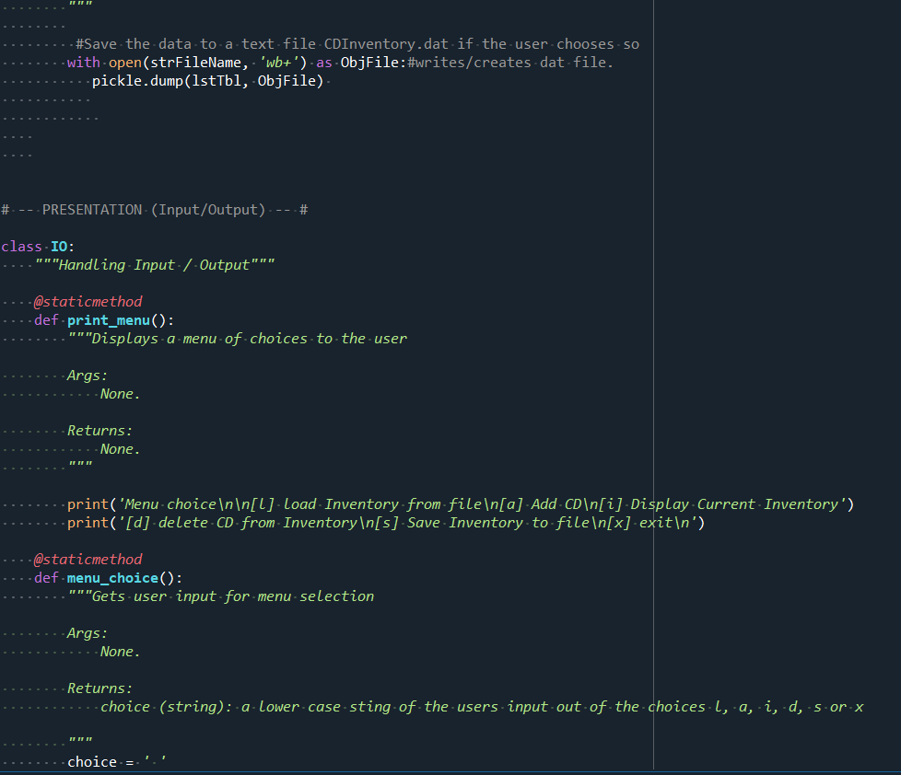

Figure IIII

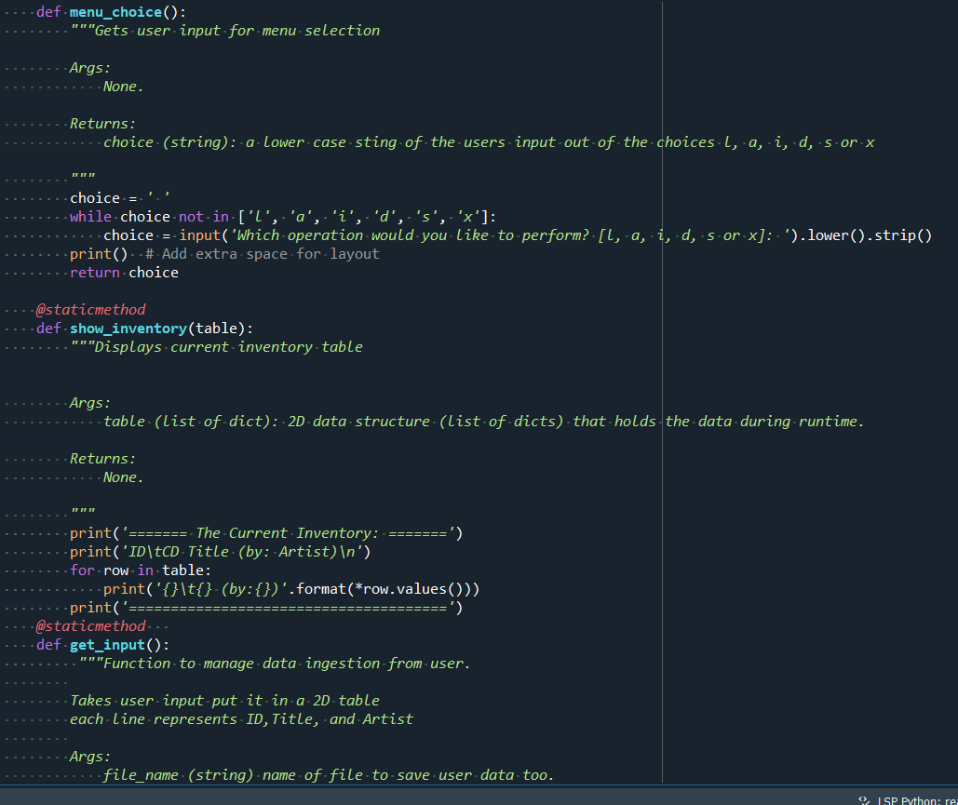

Figure V

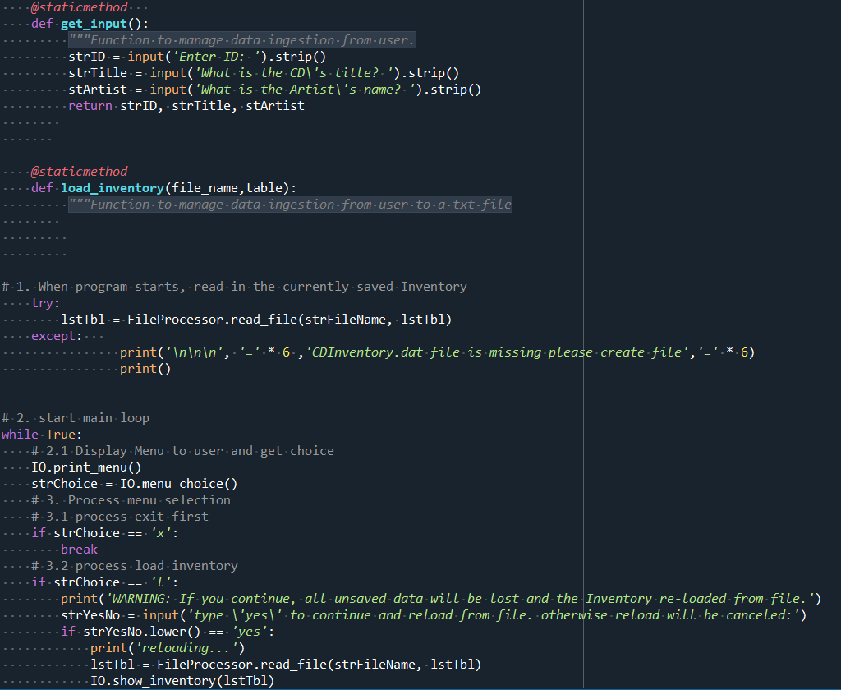

Figure IV

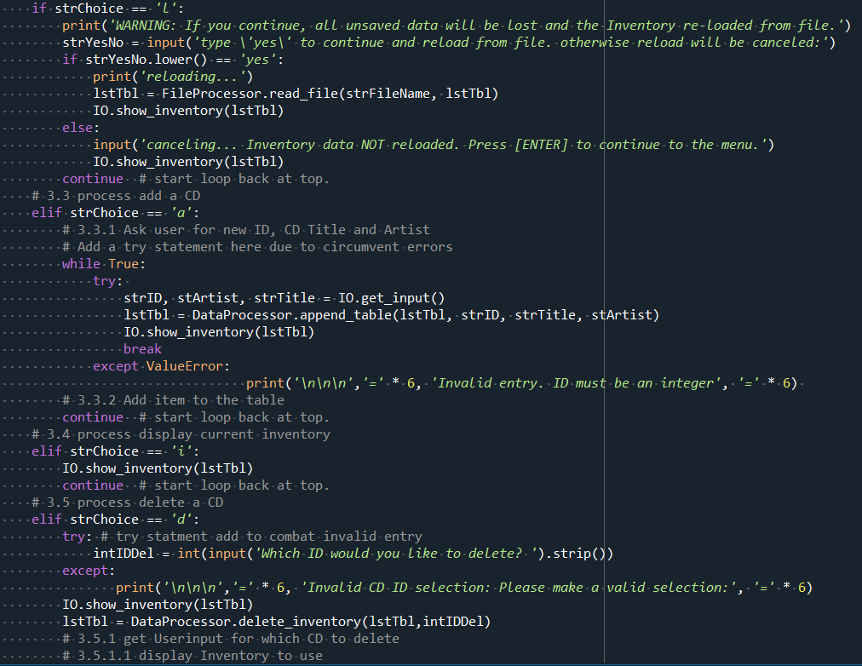

Figure IIV

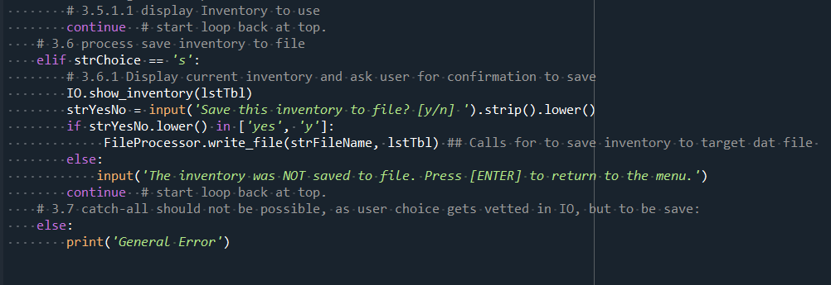

Figure IIV

**Operations:**

The output in the program displays the current inventory for the user within the program.

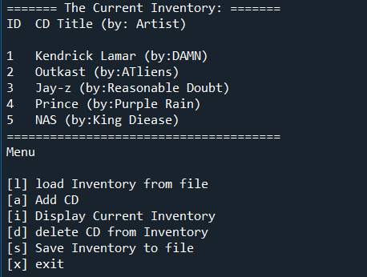

Figure V

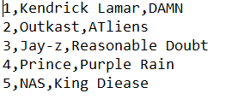

Figure IV

**Summary**

Using the textbook, the Module 06 documentation and videos, and the supplemental websites and video, I was able to successfully create a script that took the users input and wrote it to .txt file. Looking forward to improving on the concepts I have learned so far.